# Algorithm for file updates in Python

## Project description

As a security professional working at a healthcare company, it is required to regularly update a file that identifies the employees who can access restricted content. The file includes employee IP addresses that currently have access to personal patient records. The task required is to create an algorithm that uses python code to check whether the allow list contains any IP address identified on the remove list and if so, remove those IP address from the IP addresses from the file containing the allow list.

## Open the file that contains the allow list

First the allow_list.txt file path is stored to a variable “import_file”



The file is open to read using the command

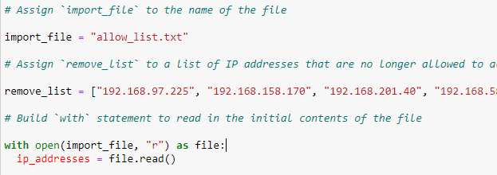

## Read the file contents

With the file open, I can now read the contents with the *.read()* method which converts the contents of the file into a python string.



## Convert the string into a list

The file contents are in the file type(str) and therefore needs to be converted into a list using .split()

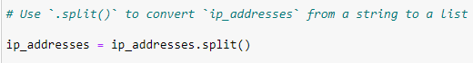

## Iterate through the remove list

Now that all of the allowed IP addresses were easily available in a list, I iterated through all of the IP addresses I needed to remove so that I could check if they existed in the currently allowed IP addresses.



## Remove IP addresses that are on the remove list

While iterating through the IP addresses to remove, I created a conditional to remove an IP address from the list of allowed IP addresses if it was currently allowed but should be removed.



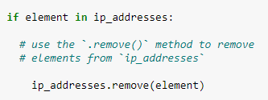

## Update the file with the revised list of IP addresses

In the final step of the algorithm, I needed to update the allow list with the revised list of IP addresses.

First the list is converted back into a string using .join() and also using the “\n” as the separator to instruct python to place each element on a new line.

Then another with statement and the .write() method is used to update the file.

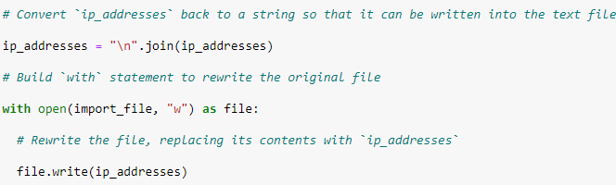

## Summary

For this task, I created a Python algorithm that takes in a file of IP addresses and uses a list of IP addresses to remove to update the file. Using Python functionalities like *with open*, *.read()*, and *.remove()* I convert the file to a Python list and iterate through the list of IP addresses to remove and compare them to the IP addresses currently listed in the file. After removing the invalid IP addresses, I convert the list back to a string to then update the valid IP addresses file with the new list.